[Insert Coalition Name]
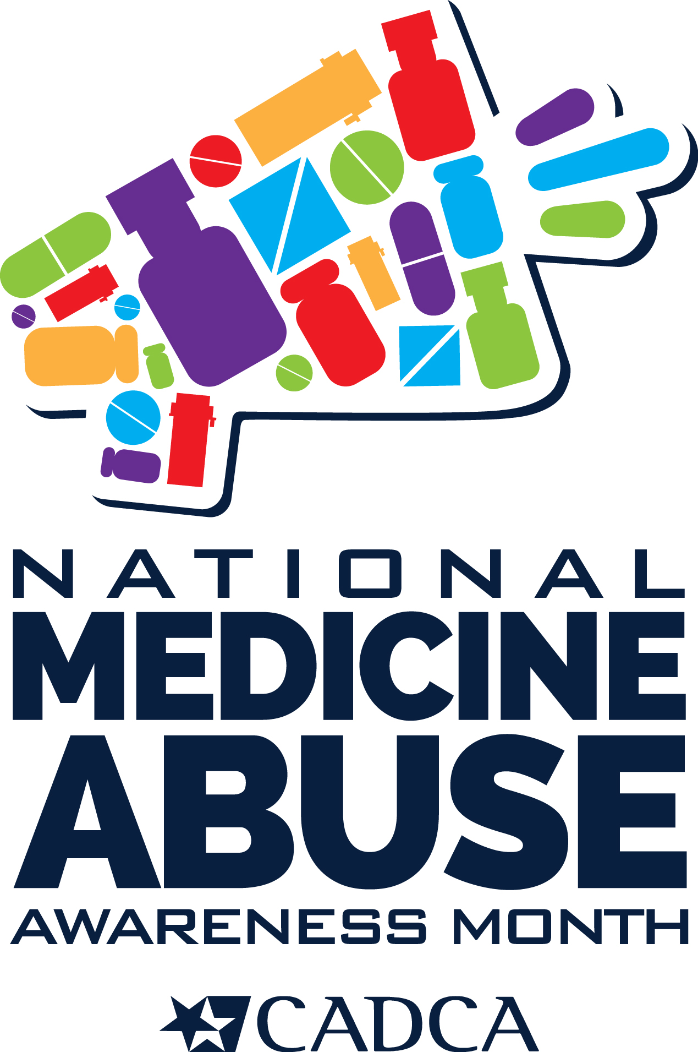
Holds Town Hall Meeting
to Discuss Community Solutions for Rx and OTC Misuse and Abuse
Event held during October’s National Medicine Abuse Awareness Month

INSERT CITY/STATE – At one point or another, we’ve all used prescription drugs or over-the- counter (OTC) medicines to alleviate an illness – whether it’s to relieve pain or curb a cough. Unfortunately, too many young people and adults are abusing these drugs for a quick high. In response to our country’s medicine abuse epidemic, the [insert coalition name] coalition is holding a town hall meeting to address this issue and receive community input on how to solve this problem at [time, date and location here].

The event will feature [names, titles, etc. of any speakers] who will cover the following information: [event specific information for your town hall and/or educational event here]

Nationally, prescription drugs are the second most abused category of drugs after marijuana, with one in five young adults reporting that they have abused a prescription drug. In addition, the 2019 Monitoring the Future Survey found that 3 percent of teens have abused over-the-counter
cough medicines containing the active ingredient dextromethorphan to get high over the past year. When abused in extreme excess—sometimes as much as 25 to 50 times the recommended dose— dextromethorphan can produce dangerous side effects, especially when combined with alcohol, illicit drugs, or certain prescription drugs.

Locally, the statistics are staggering: [insert any local or state-wide data pertaining to Rx and/or OTC abuse here]

“Our coalition has been working tirelessly to reduce and prevent medicine abuse by teens and adults since [year] through education, community engagement, and local policy changes,” said [coalition representative and title]. “By bringing together parents, educators, health professionals and other concerned citizens for this community forum we hope we can prevent further tragedies involving prescription drugs or over-the-counter medicines.”

The event is part of National Medicine Abuse Awareness Month, observed annually in October. The [name of coalition] is one of hundreds across the country holding similar events. The national campaign, sponsored by Community Anti-Drug Coalitions of America (CADCA) and the Consumer Healthcare Products Association (CHPA), aims to educate parents and youth of the potential dangers associated with prescription and OTC medicine abuse.

If you’re interested in attending this event, contact [insert coalition contact name, phone and e-mail address].

[Insert Description of your coalition or your mission statement here.]

# # #

